**PRACTICAL - 2**

**AIM:**

Introduction to Oracle (step by step installation, introduction of sql, pl/sql).

1. **Install it by double clicking .exe which you have downloaded**

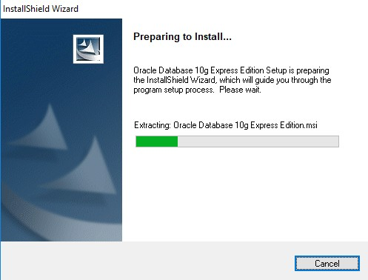

1. **Click on next button**

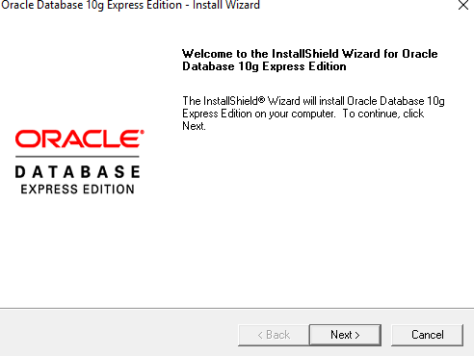

1. **Accept license agreement and click on next button  
     
   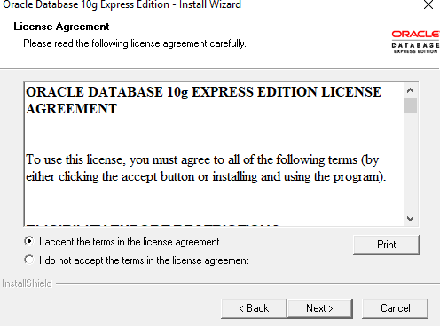**

1. **Click on next button  
     
   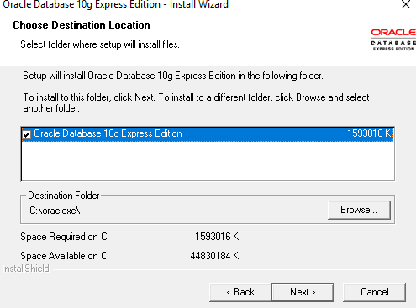**
2. **Enter password and confirm password for SYS and SYSTEM user. Please remember it because once installation will be over you have to enter it. To make it easy to**

**remember give password as : “oracle”  
  
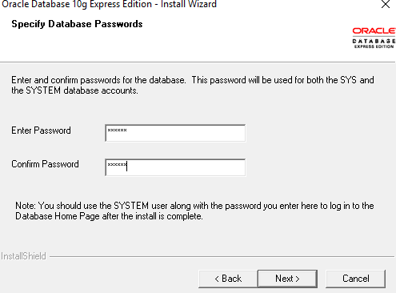**

1. **Click on install button  
     
   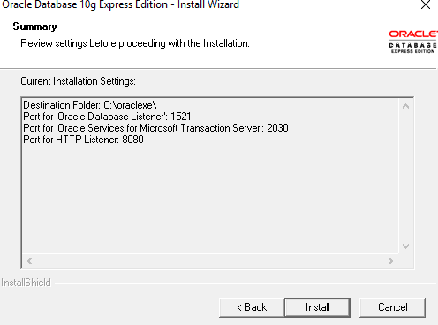**

1. **Click on finish button.  
     
   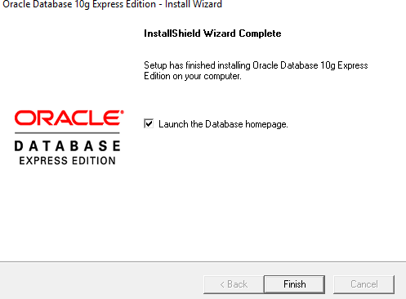**
2. **Enter username as SYS OR SYSTEM and enter your password (Entered in step: 6)  
     
   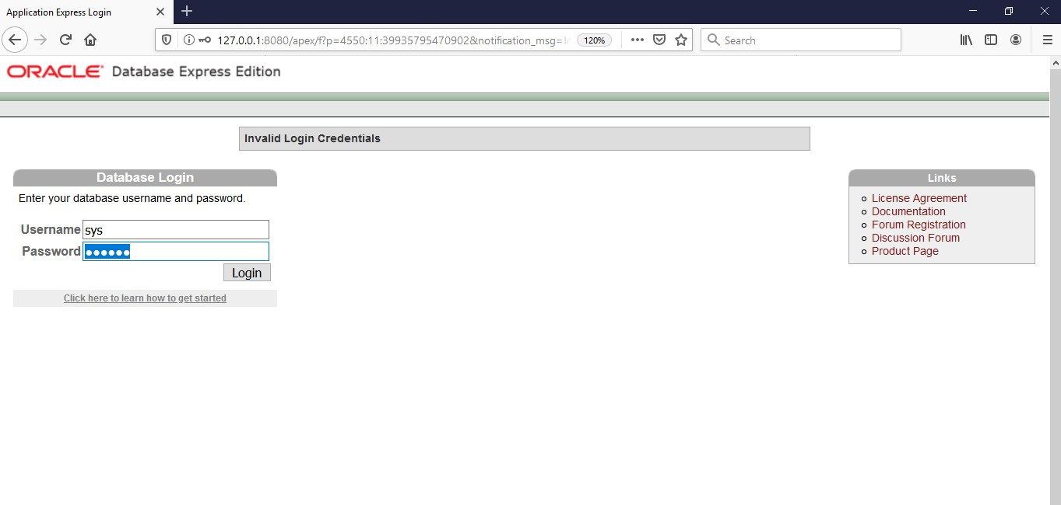**
3. **Click on Administration  
     
   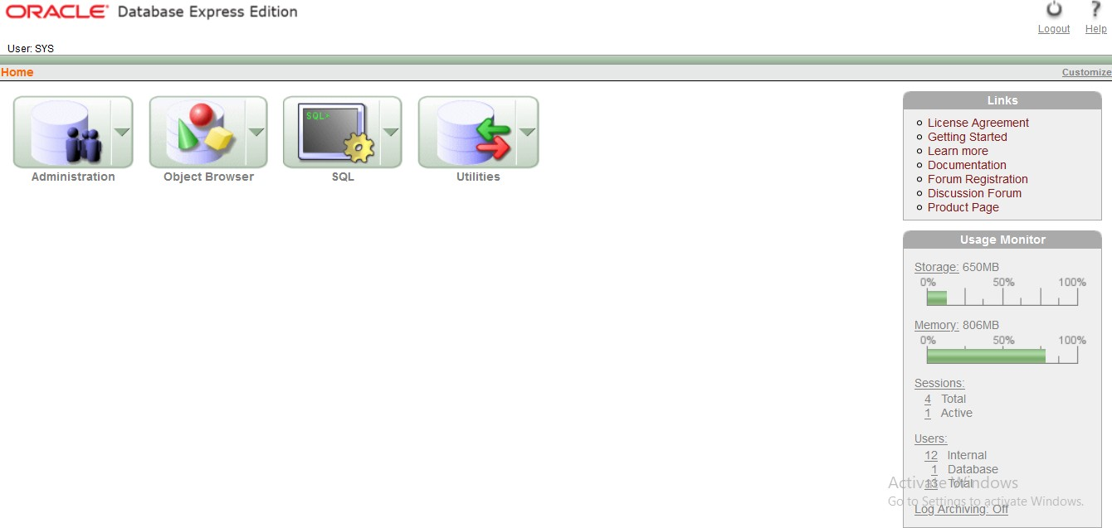**
4. **Now click on “database user drop down button”. From that click on “create user**  
   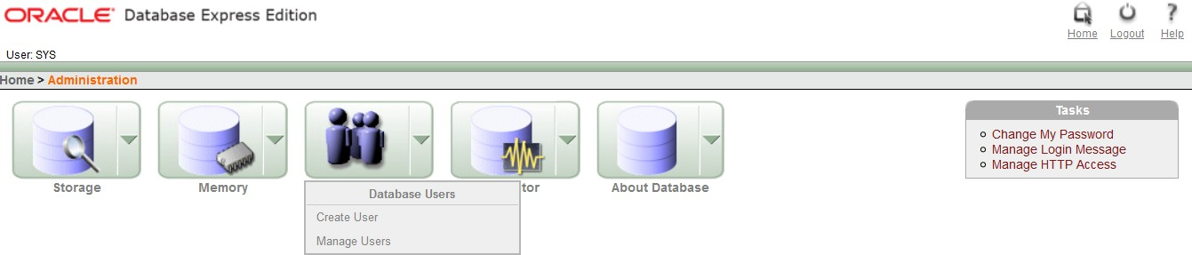
5. **Enter your college roll no in username and give password (NEW) and confirm password. Don’t check expire password, make account status unblocked if it is not. Give all privileges to your user. Finally click on “create” button.**

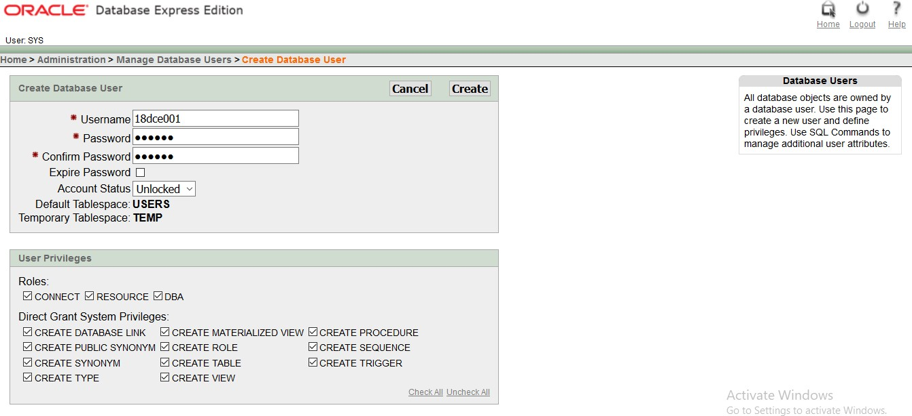

1. **This page will be shown to you. Now click on “logout” button.  
     
   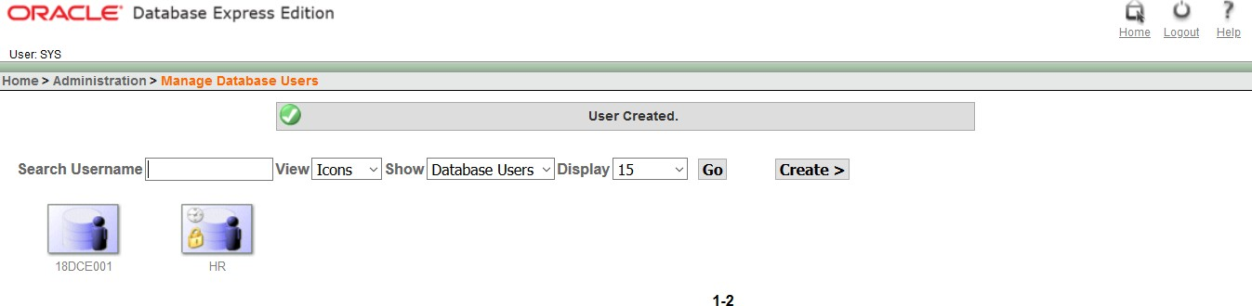**
2. **Click on login  
   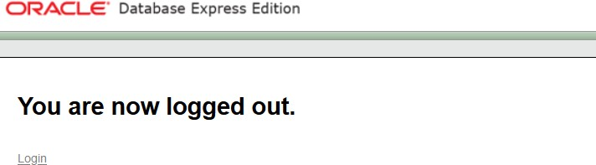**
3. **Enter username and password that you just created and click on “login” button**

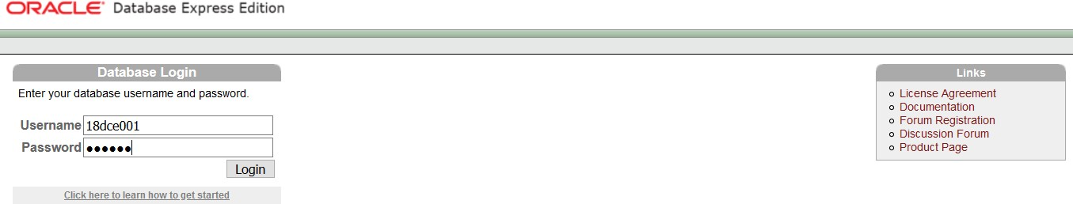

1. **Click on SQL  
     
   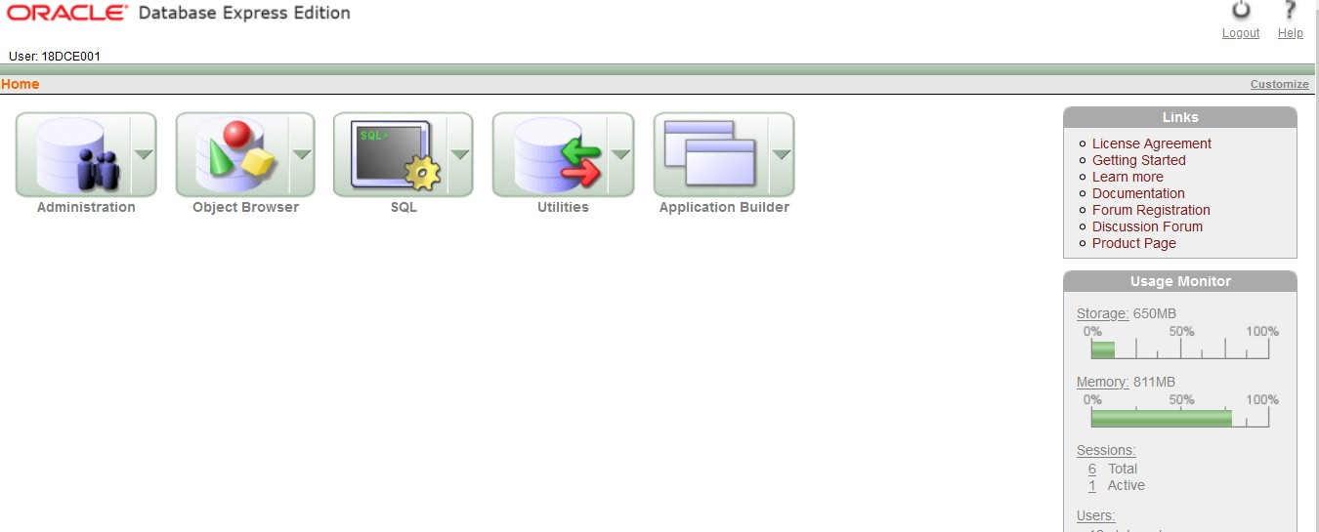**
2. **Home Screen  
     
   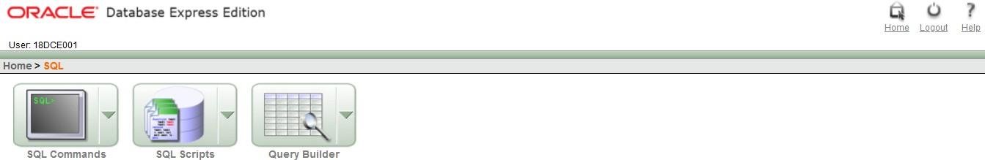**
3. **Congratulation!!! Now you are ready to code SQL and PLSQL.**

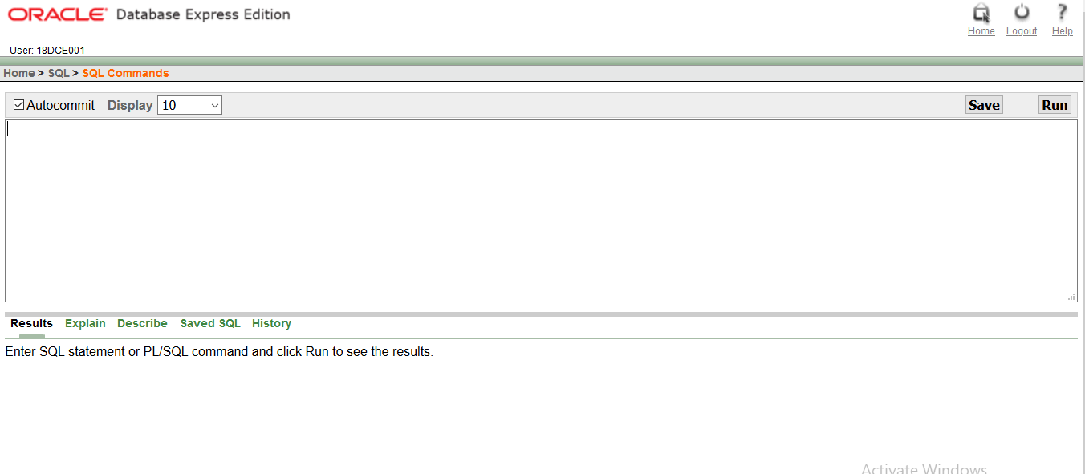

1. **Thank You**

**INTRODUCTION**

**SQL** :

* SQL is Structured Query Language, which is a computer language for storing, manipulating and retrieving data stored in a relational database.
* SQL is the standard language for Relational Database System. All the Relational Database Management Systems (RDMS) like MySQL, MS Access, Oracle, Sybase, Informix, Postgres and SQL Server use SQL as their standard database language.

Also, they are using different dialects, such as −

* MS SQL Server using T-SQL,
* Oracle using PL/SQL,
* MS Access version of SQL is called JET SQL (native format) etc.

**PLSQL :**

* PL/SQL is a block structured language that enables developers to combine the power of SQL with procedural statements. All the statements of a block are passed to oracle engine all at once which increases processing speed and decreases the traffic.